**Creating Groups in Outlook**

**In Infinite Campus…**

Step 1: On the left hand side, select **Custom Links and Reports.**

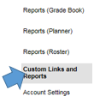

Step 2: Select **Student E-Mail Addresses.**

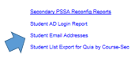

Step 3: Set Calendar to **Holicong Middle School** and pick a **Section (Class Period).**

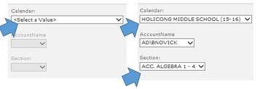

Step 4: Press “Apply,” in the bottom right hand corner.

Step 5: Select **Export** and **Excel** (under the Action tab)

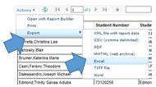

Step 6: Open the file in excel



Step 7: The file will open in Excel. Highlight and copy the e-mail addresses.

**In Outlook…**

Step 1: Click **People.**



Step 2: Select **New Contact Group.**

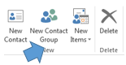

Step 3: Select **Add Members** and **From Address Book.**

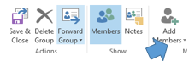 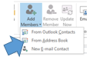

Step 4: Paste the e-mail addresses (that you copied from Excel) in **Members** and press **OK.**

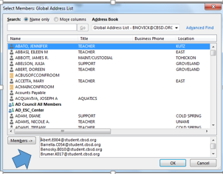

Step 5: **Name the group** and click **Save and Close**.

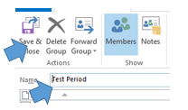

**Once you create the group, to e-mail the class (group), open a blank e-mail and enter the name of the group.**

